ASSIGNMENT -2

R Bharath kumar HALLTICKET NO : 22541A05E3

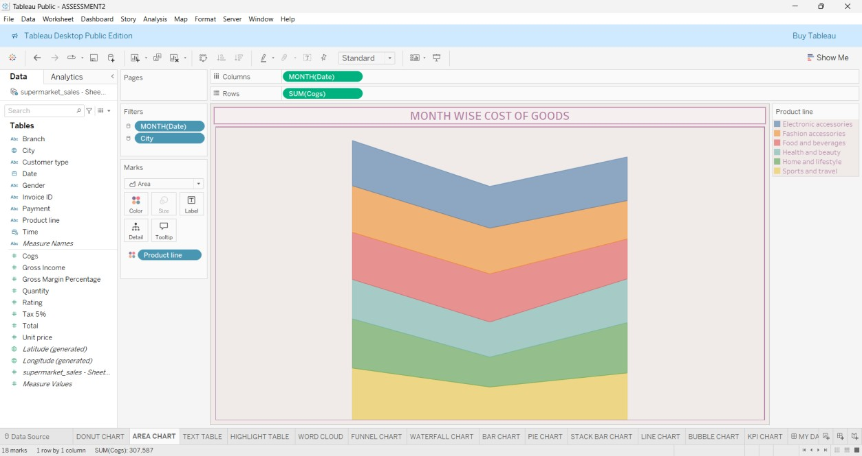
DONUT CHART
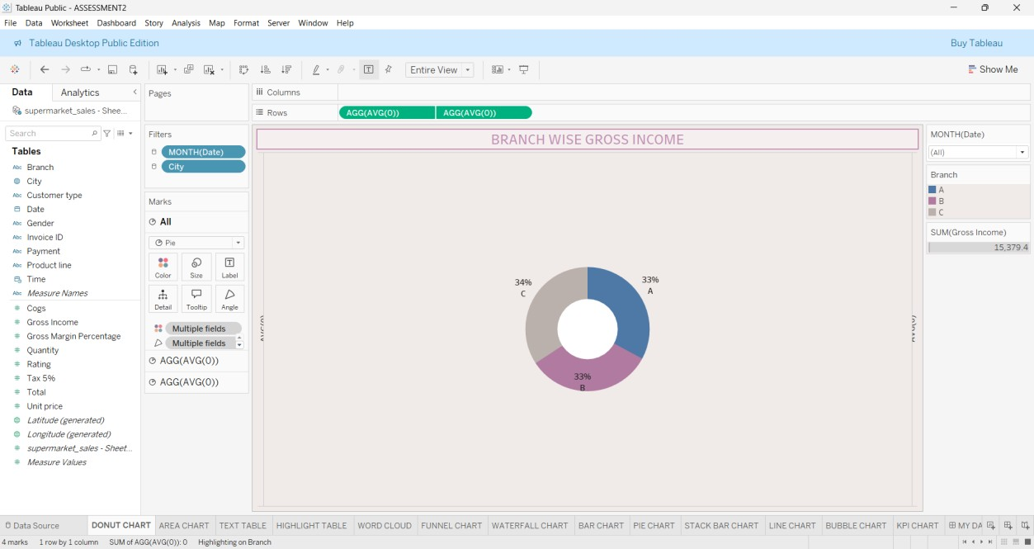

AREA CHART

TEXT TABLE
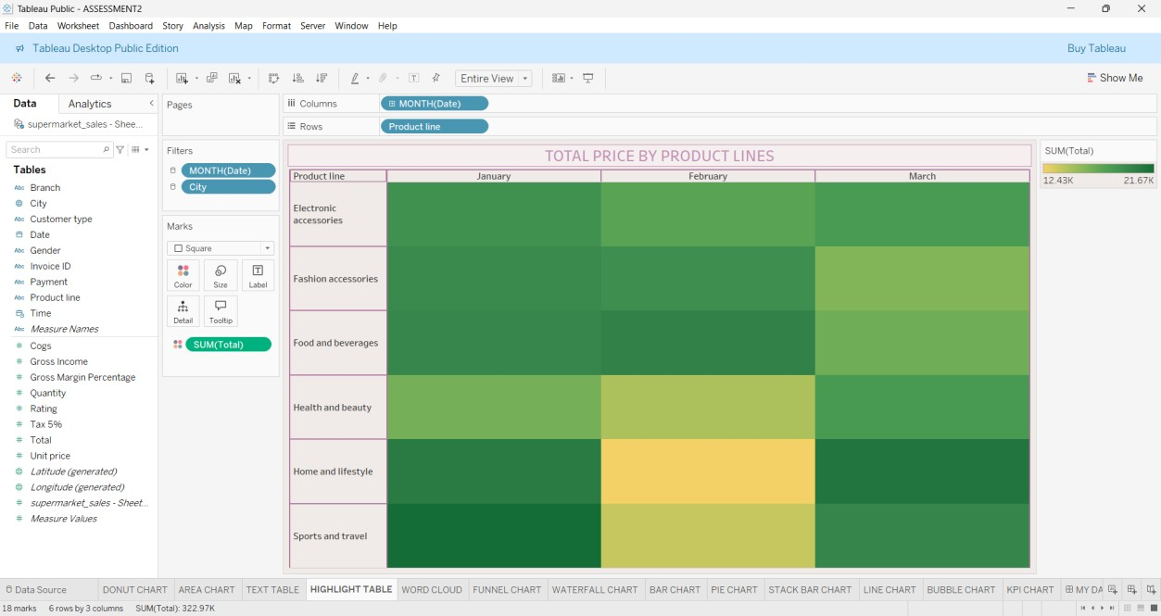
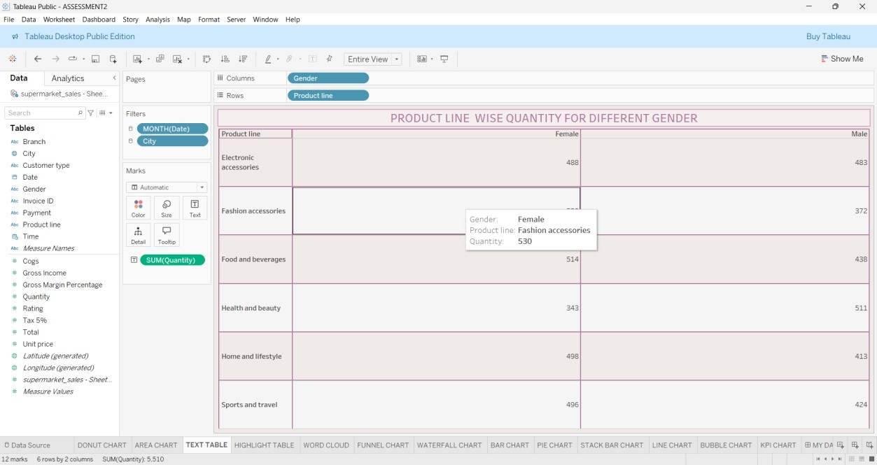

HIGHLIGHTED TABLE

WORD CLOUD
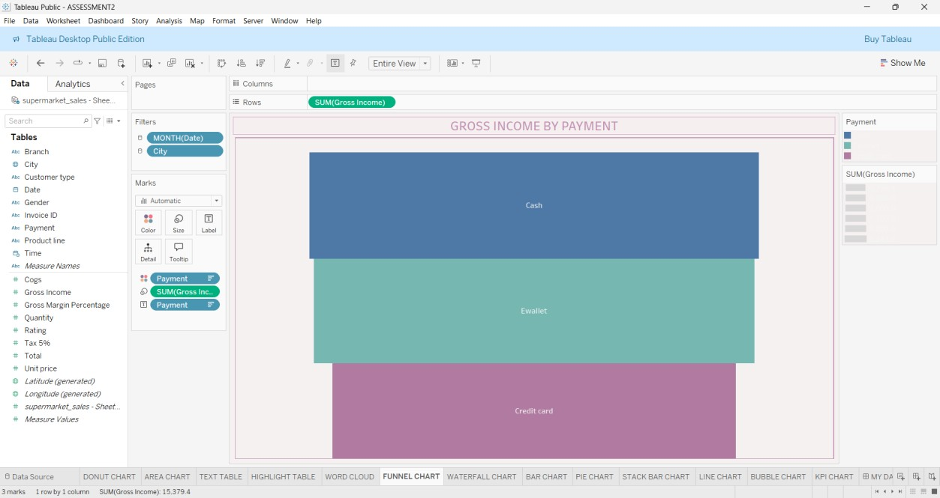
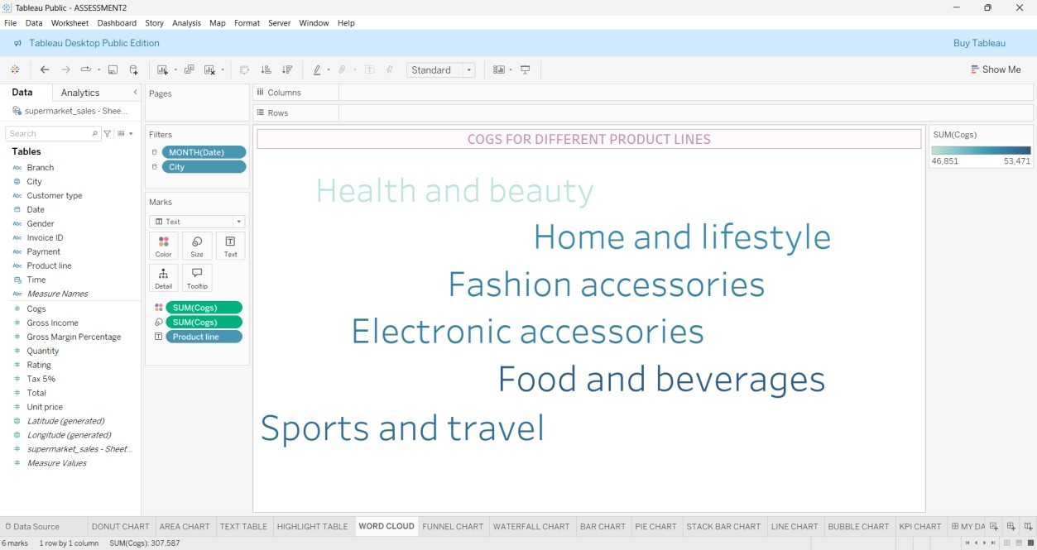

FUNNEL CHART

WATER FALL CHART

